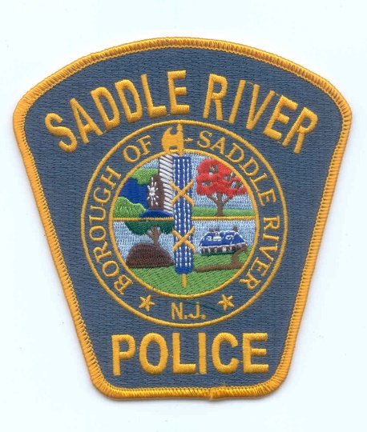

**SADDLE RIVER POLICE DEPARTMENT  
IS NOW ACCEPTING APPLICATIONS FOR**

**The Position of**

**SLEO II POLICE OFFICER**

The Saddle River Police Department is currently accepting applications for the position of Class II Special Law Enforcement (**SLEO II**) Police Officer. **Applicants must possess a SLEO II PTC certification to apply.** Job will be from 20 to 40 hours per week. Salary is between $25 and $35 per hour.

**QUALIFICATIONS**

1. No person shall be appointed as SLEO II unless he is a citizen of the United States and a resident of the State of New Jersey, is sound in body and of good health, is able to read, write and speak the English language well and intelligently and is of good moral character;
2. No person shall be appointed as SLEO II that has been convicted of any crime constituting an indictable offense or who has been convicted of any crime or offense involving moral turpitude;
3. No person shall be appointed as a SLEO II except in compliance with state statutes;
4. Must be at least 18 years of age;
5. Must be a citizen of the United States and a resident of New Jersey at the time of appointment;
6. Must possess a valid New Jersey driver's license at the time of appointment;
7. Must possess a high school diploma or G.E.D. equivalent.

**HIRING PROCESS**

1. **Application & Resume**
2. **Oral Interviews**
3. **Psychological examination**
4. **Medical examination**

Please direct questions regarding this position to [egiannotti@saddleriverpd.com](mailto:egiannotti@saddleriverpd.com)