KENNETH J. HOPKINS
MAYOR

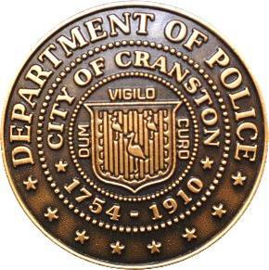
COLONEL MICHAEL J. WINQUIST
CHIEF OF POLICE

APPLICANT SWIM TEST WAIVER

To Whom It May Concern:

I, D.O.B. of

(Address)

do hereby release and forever discharge the City of Cranston, and its servants, agents and employees including all members of the Cranston Police Department, their heirs, and executors and administrators from all claims, demands, actions, both in law and equity or especially all claims of any physical or mental injury or discomfort or accidental death arising out of participating in, taking part in and being allowed to take the Cranston Police Department swim test on a date to be announced. It is completely understood that I am taking the above-mentioned action of my own free will.

Signature
Date:

Notary Public
Date:

Commission expiration

The City of Cranston is an Equal Opportunity Employer. Women and minorities are strongly encouraged to apply.

Cranston Police Department is a National Accredited Police Agency.

August 2023

