JOBS>>>>>>>>>>>>>
The Town of Watertown seeks candidates for the following position:

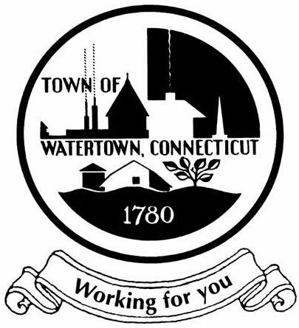

PUBLIC SAFETY CERTIFIED DISPATCHER
PART TIME
WATERTOWN POLICE DEPARTMENT
HOURLY RATE (Probation) $24.17
$26.71 After 12 Months

SUPERVISON RECEIVED: Works under the supervision of the Communication Supervisor.

DESCRIPTION OF DUTIES: Answers emergency and non-emergency calls for service. Dispatches and monitors radio traffic and location information for the police and fire department. Follows Emergency Medical Dispatch protocols over the telephone. Provides assistance and information as requested by other police and fire agencies. Operates a computer aided dispatch system and computerized electronics communication equipment. Monitors security and prisoner cameras. Assists the public in matters of general police information. Obtains information on wanted persons. Obtains motor vehicle license and registration information. Performs other related duties as may be assigned by the Communications Supervisor, Police Chief and/or Fire Chief.

KNOWLEDGE, SKILLS AND ABILITIES: Must have good ability to communicate orally and in writing; Good working knowledge of computers and the ability to navigate within a Windows operating system; Good ability to establish and maintain effective working relationships with superiors, co-workers and the general public. Good knowledge of Watertown and Oakville and the ability to multi task. State of CT Telecommunicator certification required.

Weekly hours range from 8-40 hours including nights, weekends and holidays.

APPLICATION PROCEDURE: Applications are accepted through https://policeapp.com/ No phone calls will be accepted. The Town of Watertown is an Equal Opportunity Employer.

7/2022

