BRISTOL POLICE DEPARTMENT APPLICANT INFORMATION BOOKLET

395 Metacom Ave
Bristol, RI 02809

(401) 253-6900

Steven Contente Town Administrator Bristol, Rhode Island

Nationally Accredited

Kevin M. Lynch Chief of Police Bristol, Rhode Island

Kevin M. Lynch
Chief of Police

Bristol Police Department
395 METACOM AVENUE, BRISTOL, RHODE ISLAND 02809 TELEPHONE (401) 253-6900

If you are interested in a rewarding career with the Bristol Police Department, this applicant information booklet will provide you with the minimum hiring requirements, various phases of the applicant selection process, recruit training requirements, salary and benefits, and other miscellaneous information.
Applications may be obtained from www.PoliceApp.com/BristolRI beginning Wednesday, November 9, 2022, and completed no later than 11:59 PM on Friday, February 3, 2023.

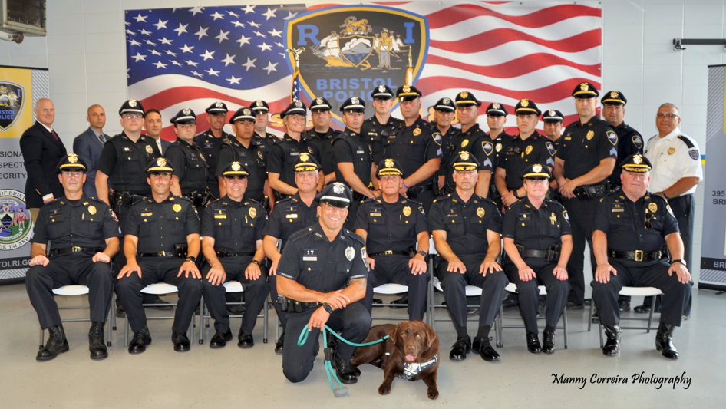

THE TOWN OF BRISTOL IS AN EQUAL-OPPORTUNITY EMPLOYER

Kevin M. Lynch Chief of Police

Bristol Police Department
395 METACOM AVENUE, BRISTOL, RHODE ISLAND 02809 TELEPHONE (401) 253-6900

TABLE OF CONTENTS

Mission Statement 3 Equal Employment Opportunity Statement 3 Job Summary 3 General eligibility requirements 4 Physical requirements 5 Educational requirements 6 Personal survey requirements 6 Phases of the applicant selection process 6 Recruit rules and regulations 8 Training requirements 8 Salaries and benefits 9 Expected duration of the selection process 10 Re-application, retesting and re-evaluation procedures 10 Miscellaneous information 10

MISSION STATEMENT

We the members of the Bristol Police Department. In cooperation with the people of Bristol and partnership with other public and private agencies, to assume a leadership role through a problem-solving approach to preventing crime and disorder, reducing citizen fear of crime, providing for the safe and efficient flow of traffic, providing a variety of non-criminal activities, and improving the quality of life as we work together to make Bristol truly New England's outstanding "community by the sea."

Employment
The Bristol Police Department is an Equal Employment Opportunity Employer

Equal Employment Opportunity Statement

It is the policy of the Bristol Police Department to identify and employ the best-qualified individuals to perform the tasks and functions of the department without regard to race, color, religion, sex, age, national origin, or physical disability.

The department prohibits discrimination against any person in recruitment, appointment, training, promotion, retention, discipline, or any other aspect of personnel administration for reasons of political or religious opinions, affiliations, or because of race, color, national origin, physical disability, or age, except where specific age or physical requirements constitute a bonafide occupational qualification necessary to properly and efficiently perform the functions of the job.

It is the policy of the department to actively encourage women and minorities to apply for employment in all positions within the department. The department maintains an Equal Employment Opportunity plan through which management assures that all persons have equal opportunities in recruitment, selection, appointment, promotion, training, discipline, and related areas.

JOB SUMMARY

Serves as a Patrol Officer performing responsible law enforcement duties, including patrol, investigation, collection, and preservation of evidence, traffic control, delivery of crime prevention and community policing services, and a variety of other duties designed to preserve peace and order and to protect life and property in the Town.
The Bristol Police Department provides twenty-four-hour and seven-day-a-week law enforcement service. Patrol Officers fill four (4) shifts and work four (4) days followed by two (2) days off.

Administrative Personnel work Monday through Friday, five (5) days followed by two (2) days off, including holidays off.

GENERAL ELIGIBILITY REQUIREMENTS

- The goal of the recruitment process is to aggressively recruit qualified candidates by providing maximum public awareness and access to all segments of the population.

- Qualifications: All applicants for the position of police officer must meet the following standards and requirements:

  - Must be a United States citizen

  - Must be at least 21 years of age on or before appointment to a probationary police officer

  - Must possess a valid motor vehicle operator’s license

  - Shall have satisfactorily completed four years of accredited high school or the equivalent thereof.

  - If he/she has served in the armed forces of the United States or a foreign country, he/she shall have received a discharge therefrom under honorable conditions.

  - Cannot have been convicted of or otherwise admitted to having committed any felony in a court of law. A conviction or admission to a misdemeanor may be considered a disqualifying factor depending upon the totality of the circumstances (i.e., sentence, facts and circumstances surrounding the incident, distance in time, nature of the incident).

  - Must be of good moral character and habits and successfully passed a background investigation.

  - Must be in good health and meet physical, medical, and psychological requirements for entry into the Rhode Island Municipal Police Academy.

PHYSICAL SKILLS REQUIRED

Must be able to function as a working police officer, including the ability to make physical custody arrests of forcibly resisting persons, search and handcuff prisoners if required.

Must be able to qualify with a service weapon and utilize a baton and other self-defense equipment. This includes firing a firearm from standing, crouched, kneeling, and prone positions and from behind cover, clear weapon malfunctions, fire weapon in a dark environment while using a flashlight, discharge a shoulder weapon, and clear malfunctions in various firearms.

Must be able to operate a standard police vehicle under both emergency and non-emergency driving conditions. May be required to operate a police mountain bicycle or police motorcycle.

Must be able to use physical force to gain entry to premises and subdue or control persons, break up fights, disarm violent persons, etc.

Must be able to engage in foot pursuits of fleeing suspects, climb up and downstairs, over walls and fences, push motor vehicles and lift and carry heavy objects.

Must be able to hear well enough to distinguish direction and content of conversations in person and over the radio and telephone, even in the presence of background noise.

Must be able to administer first aid and cardiopulmonary resuscitation.

Must be able to see well enough to read and fill out forms in artificial lighting conditions, and able to aim and fire a weapon without corrective lenses in an emergency.

Must be able to stand or sit for protracted periods during surveillance situations, traffic duty, etc.

Must be able to speak English clearly and distinctly enough to use a police radio, speak to groups, or be overheard when giving commands during a crowd control situation.

Must be able to read, comprehend, analyze and explain complex written materials pertained to law enforcement.

Ability to use a personal computer to produce reports with a word processing system, and to access the database to obtain information on wants and warrants, stolen vehicles, etc.

Must be able to maintain the physical standards required by the department.

Must be able to remain calm and think clearly in emergencies, and to adapt to both long-term and short-term stress.

EDUCATIONAL REQUIREMENTS

He/she shall have satisfactorily completed four years of accredited high school or the equivalent thereof.
If he/she has served in the armed forces of the United States or a foreign country, he/she shall have received a discharge therefrom under honorable conditions.

PERSONAL SURVEY REQUIREMENTS

The applicant will be required to provide three references that are reputable citizens of their communities and are willing to attest to the applicant’s character and reputation. The references must have known the applicant for the last five years. The references may not be a present or former employer, any relatives by blood or marriage, or school teachers.

Applicants must have a high ethical standard demonstrating respect, integrity, and professionalism.

PHASES OF THE APPLICANT SELECTION PROCESS

- Physical Fitness Test:

  - A physical fitness test, which uses valid, useful, and nondiscriminatory procedures, shall be administered during the selection process, and before the start of the Rhode Island Municipal Police Academy (RIMPA). The minimum level of physical fitness for new officers entering the RIMPA shall be consistent with RIMPA minimal performance entrance requirements or any other minimal physical fitness entrance requirements promulgated by the academy.

  - Such examinations may be conducted before extending a conditional offer of employment to candidates.

  - The Department’s physical fitness test battery consists of the four (4) following basic tests. The minimum fitness standards will be made available before the fitness orientation and can also be found at the RI Municipal Police Academy Web site (www.rimpa.ri.gov).

    - 300 Meter Run
    - 1 Minute Sit-up Test
    - 1 Minute Push-up Test
    - 1.5 Mile Run

The actual performance standard for each test is based upon norms for a national population sample.

  - A physical fitness test should identify qualified candidates and reduce the probability of work-related disabilities.

- Written Examination:

A written examination, which uses valid, useful, and nondiscriminatory procedures, shall be administered during the selection process, before the start of the Rhode Island Municipal Police Academy.

- Oral Board Interviews:

Oral board interviews, which use valid, useful, and nondiscriminatory procedures, along with standardized criteria, shall be conducted during the selection process, before the start of the recruit training academy.

- Background Investigations:

The applicant background investigation phase of the selection process is a comprehensive background check and shall include verification of a candidate’s qualifying credentials, such as educational achievements, employment and credit history, neighborhood references, citizenship, etc. A review of the candidate’s criminal record, motor vehicle operator’s license history, credit history, and verification of at least three personal references of the candidate

- Conditional Offer of Employment:

Upon successful completion of the written examination, physical fitness test, oral board interview, and applicant background investigation, certain candidates will be tendered conditional offers of employment.

- Psychological Examinations:

  - A battery of psychological test instruments, which use valid, useful, and nondiscriminatory procedures, shall be administered during the selection process, before the start of the Rhode Island Municipal Police Academy.

  - Psychological examinations shall be conducted post-conditional offer of employment.

  - No person shall be appointed as an officer of the Department until such member has been tested and evaluated with standardized procedures by a certified psychologist, consistent with the provisions of Section 42-28.3-1 and Chapter 44 of Title 5 of the Rhode Island General Laws.

  - The psychologist shall provide a report, in writing, of his/her evaluation, together with pertinent recommendations for the guidance of the appointing authority, in considering the total fitness of a said person for the appointment. Any candidate who receives an unsatisfactory rating shall be ineligible for appointment, consistent with the provisions of Section 42-28.3-1 of the R. I. General Laws.

- Medical Examination

  - A medical examination, which uses valid, useful, and nondiscriminatory procedures, shall be conducted.

  - Medical examinations shall be conducted post-conditional offer of employment.

  - Only licensed physicians shall be used to certify the general health of candidates.

  - The Department shall investigate the health of candidates to identify any medical problems that might inhibit work performance, shorten a career or contribute to work-related disabilities. Consequently, the Department and the candidate can be made aware of any medical condition likely to cause an employment problem.

RECRUIT RULES AND REGULATIONS

Recruits must attend all events and have in possession a valid motor vehicle operators’ license. The attire for the events is professional business dress.

Applicants are to wear solid plain athletic clothing for the agility test (no large images or wording). Wristwatches and accessory jewelry such as necklaces and bracelets are not permitted at the physical agility test.

Respect and courtesy toward fellow applicants and staff are expected at all times.

RECRUIT TRAINING REQUIREMENTS

All applicants hired by the Town of Bristol will be trained at the Rhode Island Municipal Police Academy located within the Flanagan Campus of the Community College of Rhode Island, Lincoln, Rhode Island. The training academy class is twenty (20) weeks. During the training process, recruits must:

- Successfully complete all academic courses, obtaining a minimum overall score of 70 percent in each course.

- Qualify with their department-issued service weapon, in accordance with Rhode Island State Law.

- Successfully complete a progressive running program designed to strengthen the cardiovascular and cardio-respiratory systems, and increase aerobic capacity.

- Successfully complete a basic water safety course.

- Successfully complete pursuit and defensive driving course and demonstrate a high level of proficiency during this course of training.

SALARIES AND BENEFITS

The stated benefits are enumerated in the existing collective bargaining agreement between the Town of Bristol and the International Brotherhood of Police Officers, Local #304, effective July 1, 2021, to June 30, 2024, and are subject to change.

Salary

Police Training Academy Cadets are not covered by the contract agreement and therefore their salary is governed solely by the Town of Bristol. Presently a Cadet’s bi-weekly salary is $2,295.12.

Upon graduation from the Rhode Island Police Training Academy, cadets are sworn in as Probationary Patrol Officers and their salary is governed by the contract agreement set forth between the Town of Bristol and the International Brotherhood of Police Officers, Local 304.

Presently a Probationary Patrol Officer’s annual salary is $59,673.22. Presently a Second Class Patrol Officer’s annual salary is $62,602.85. Presently a First Class Patrol Officer’s annual salary is $70,771.41.

Health care benefits

Health care benefits with a co-payment, an amount per pay period equal to twenty percent (20%) of the cost to the Town of such employee’s annual complete medical coverage, and dental divided by the total number of pay periods per fiscal year.

Longevity

- Completion of five (5) years of service five (7) percent of their annual salary
- Completion of ten (10) years of service eight (8) percent of their annual salary.
- Completion of sixteen (15) years of service nine (9) percent of their annual salary.
- Completion of twenty (20) years of service__________ 10 (10) percent of their annual salary.

Vacation

- Completed one (1) year and less than two (2) years eight (8) working days
- Completed two (2) years and less than five (5) years fourteen (14) working days
- Completed five (5) years and less than ten (10) years nineteen (19) working days
- Completed ten (10) years and less than sixteen (16) years twenty-four (24) working days

- Completed sixteen (16) years and less than twenty (20) years ___ twenty-seven (27) working days
- Completed twenty (20) years and more twenty-seven (28) working days

- There are twelve (12) paid holidays per year. In addition, V-J Day, Martin Luther King Day, and State and National Election Day in November will be paid holidays as long as they are recognized by the State of Rhode Island.
- Upon completion of the probationary period, each member is provided with two (2) personal days per year, per the current contract.

EXPECTED DURATION OF THE SELECTION PROCESS

The recruitment and selection process takes approximately six (6) months to complete. Vacancies within the Department will determine the number of applicants selected to attend the Police Academy.

RE-APPLICATION, RETESTING, AND RE-EVALUATION PROCEDURES

Previous applicants interested in applying are welcomed and must complete a new application. Previous applicants must complete all phases of the recruitment process again and will be re-evaluated.

MISCELLANEOUS INFORMATION

Polygraph Examinations

The use of polygraph examinations as a condition of employment or continued employment is expressly prohibited by Section 28-6.1-1 of the Rhode Island General Laws.

Uniforms

All uniforms required must be purchased by the recruit and will be reimbursed in five annual installments.

Transportation

Recruits must provide their own transportation to and from the Training Academy.

Probation Period

Recruits who successfully complete the Training Academy are subsequently appointed as sworn police officers of the Bristol Police Department and begin a one (1) year probationary period.

www.PoliceApp.com/BristolRI

