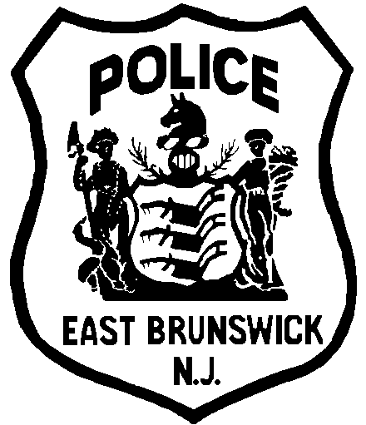
EAST BRUNSWICK POLICE DEPARTMENT

POLICE OFFICER

JOB DESCRIPTION

GENERAL STATEMENT OF DUTIES

Patrol an assigned area within the jurisdiction of the township; protect life and property, prevent crime, enforce all laws and ordinances, preserve the peace, investigate violations, and maintain order; may serve as a detective or a juvenile officer.

SUPERVISION RECEIVED

Operate under the direct command of a lieutenant and the working supervision of a sergeant.

ESSENTIAL FUNCTIONS

- Patrol an assigned area by car, checking business establishments as to their security after closing hours, checking vacant houses, investigating suspicious persons, investigating motor vehicle accidents, responding to emergency calls and fire alarms, and assisting motorists and pedestrians in distress.

- Protect municipal property and the rights and privileges of the public by enforcing State, County, and Municipal laws and ordinances; arrest and process offenders; interview witnesses; issue summonses; and make preliminary investigations of indictable and non-indictable offenses.

- Protect school and church crossings as required, and direct traffic at congested intersections or at scenes of fire, highway accidents, or traffic hazards.

- Take charge in cases of accidents or other emergencies; locate missing or lost children.

- Perform foot patrol as required.

- Serve warrants and subpoenas; testify in court as a witness to accidents, crimes, or other violations.

- Prepare and submit reports on accidents, arrests, property damage, or other unusual occurrences.

- Maintain firearms, vehicles, and other assigned equipment in proper condition at all times. Must qualify in the use of all assigned firearms.

- Conduct criminal investigations as assigned and prepare field reports in accordance with proper procedure.

- Interview juveniles or parents when investigating juvenile crimes.

- Appear before county courts, including juvenile court and grand jury as required.

ADDITIONAL RESPONSIBILITIES

- Investigate cases of reported animal bites; apprehend animals when necessary, in emergencies.

- Report conditions needing correction such as street or highway construction, extinguished street or traffic lights, or missing signs.

- Perform the duties of a desk officer or the duties of a sergeant upon assignment.

- Coordinate school safety patrols, and participates in traffic safety educational programs and other crime prevention and educational programming.

- Perform other related work as required or assigned by superior officers in conformance with the Standard Operating Procedures of the Department of Public Safety.

- Monitor and enforce safety violations on commercial vehicles.

- Inspect roadway construction sites to ensure compliance with applicable safety regulations.

- Perform traffic safety-related studies and analyses.

