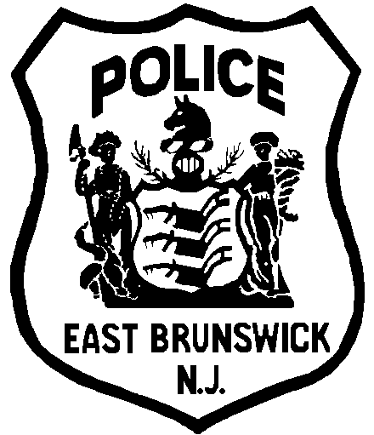
EAST BRUNSWICK POLICE DEPARTMENT

2025 RECRUITMENT DRIVE

MINIMUM QUALIFICATIONS

Before an applicant can be considered or even permitted to participate in the testing process, you must meet the following minimum requirements:
- You must be a citizen of the United States and a resident of New Jersey on the date of the appointment;
- You must possess a valid NJ driver's license by the date of appointment;
- You must no less than 18 years of age on the date of the written exam, or more than 35 years of age at the time of appointment. In accordance with New Jersey Statutes, age exemptions for military service and prior law enforcement service may be granted to meet the maximum age standards;
- You must have visual acuity of 20/100 in each eye without artificial correction, 20/30 corrected;
- You must have normal color perception, normal depth perception, and normal peripheral vision;
- You must have auditory acuity at or below 25db in each ear;
- You must be physically capable of meeting the mandatory firearms qualifications mandated by attorney general guidelines;
- You must be psychologically fit to perform all the duties of a police officer;
- You must meet the requirements that are set forth in the job description for a police officer in every respect. Copies of the job description are available for inspection at the time of registration;
- By the time of appointment, you must possess a minimum of 60 credits from an accredited college or university, or 30 college credits along with 2 years of active military or NJ PTC certification (BCPO or SLEO-1).

